THE MAHARAJA SAYAJIRAO UNIVERSITY OF BARODA
FACULTY OF SCIENCE
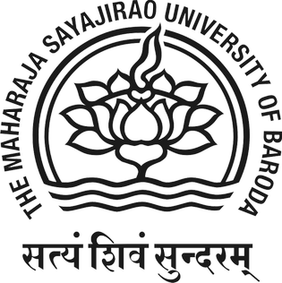
INTERNSHIP REPORT
As
ANDROID DEVELOPER
For
Submitted By:
PRN:
In fulfillment for the award of the degree
Of
Master of Science in Information Technology.
In
The Department of Computer Applications
Internal Guide: | External Guide:
Priti Patel | [External Guide]

